Document Name | Business Requirements Specifications
Project Name | Processing Services (Print and Ship)
Group Name | ADE

Document Version | 1.0
Documents Reviewed
Template Version
Template Release Date
PROCESS ASSETS LIBRARY LINKS
Project Repository | Link to sharepoint

DOCUMENT POINT OF CONTACT
For issues or questions related to document content, document control, location or access, please notify the contact(s) below:
Name | Org/Group | Role | Phone
 | ADE | BA
 | ADE | BA

REVISION HISTORY
Rev. # | Date | Sect./Page # | Revision Summary | Author
1.0 | 01.03.18 | All | Initial Draft | Satish Pala Kumar
1.1 | 07.11.18 | All | Added Mock ups | Pavan Samudrala
1.2 | 08.08.18 | All | Removed the info which are not related to Billing | Pavan Samudrala

Definitions List

TABLE OF CONTENTS
1.0 Project Background 4
1.1. Project Charter 4
1.1.1. Project Objective 4
1.1.2. Scope 4
1.1.3. Success Metrics 5
1.2. Project Impact Summary 6
1.2.1. Features and Functions 6
1.2.2. Assumptions, Dependencies, and Constraints 7
2.0 People and Process Requirements 8
2.1. Current Business Environment 8
2.2. Target Business Environment 8
2.3. Detailed People and Process Requirements 9
3.0 Use Cases and/or Scenarios 10
3.1. Actors and Roles 10
3.2. Use Case List 11
3.3. Use Case and/or Scenario Details 11
4.0 Engineering Requirements 12
4.1. Current Technology Environment 12
4.2. Target Technology Environment 12
4.3. Functional Requirements 13
4.4. Other Technology Requirements 14
4.4.1. Design Considerations 14
4.4.2. Implementation Impacts 14
4.5. Information Environment 15
4.6. Non-Functional System Requirements 15
5.0 Opirement Issues 17
6.0 Reviews and Approval Summary for Baselien Requne 18
6.1. Reviews 18
6.2. Baseline Approval Summary 18
7.0 Appendix 19
7.1. Related Documents 19
7.2. Definitions 19

Project Background

Project Charter
.

Project Objective
This project involves the process improvement steps need for all print and ship projects involving shipping at a system wide level and not client specifc to reduce the amount of manual efforts currently in place as well as streamlining aspects of the process so it runs more efficiently. Software Development will be required. All requirements in section 4.3 must be at a systemic level unless written other wise.

CURRENT SYSTEM: See below

FUTURE SYSTEM: See below

Scope
Systems
- AuthoMail

Business Groups
- Printing and Shipping

Loans / Programs
- All Shipping Clients

Success Metrics
No. | Description | Unit | Current Baseline | Project Target | Lower Spec Limit  (Value above which performance is acceptable) | Upper Spec Limit  (Value below which performance is acceptable) | How is it Measured? | Responsible for Tracking Performance
 | Primary & Secondary Metrics
 | Critical to Quality Metrics

Project Impact Summary

Features and Functions

Feature /Function  ID # | Priority  (H, M, L) | Ties to  Success Metric # | Feature and Function Description  <Role> wants <function to be provided> so that <benefit or business value obtained>

Assumptions, Dependencies, and Constraints
# | Assumptions, Dependencies, & Constraints | Raised by (optional) | Confirmed By | Date
 | Assumptions
 | Dependencies
 | Constraints

People and Process Requirements

Current Business Environment
Current processes have an abundant number of manual checks/intervention requirements that need to be converted from manual to automated. Onboard all print and ship clients to AuthoMail application, systemic level changes are required to allow for a more fluid process.

Target Business Environment

Improvement of the various aspects of the Printing and Shipping process.
- All clients on AuthoMail application
- Manual process elimination
- Quick TAT in reporting & Billing

Detailed People and Process Requirements

Traces To [Success Metric] | User Req ID | Priority  1 Essential  2 Critical  3 Nice to Have | Category | Process Step | User Requirement Statements  (that is, Non Technical People and Process)
1 | 1 | 1 | Status Reporting | Automated report | Support user need to receive the report on daily basis for all clients
2 | 2 | 2 | Access | User access | All Support users should have access to Print & Ship mail box to receive the reports and alert emails
3 | 3 | 1 | Alert emails (trigger) | Status Communication | All alert emails should be sent to common mail box instead of users individual mail box
4 | 4 | 1 | Billing Report | Report Format | Users should be trained on all the reports and billing line items to represent/understand the numbers properly for verification

Use Cases and/or Scenarios

Actors and Roles
Actor  # | Actor/Role | Org/Group(s) Performing Role | Description (responsibilities, tasks, goals) | Representative(s)

Use Case List

Traces to | Use Case # | Use Case Name | Description | Actors | Success Criteria

Use Case and/or Scenario Details

Engineering Requirements

Current Technology Environment
Current environment is more manual than automated

Target Technology Environment

Change to a more automated and less manual process within AuthoMail.

Functional Requirements

Priority definitions:

1 Essential – Mission critical requirement; required for current implementation
2 Critical – Required eventually but could wait until a later release, if necessary
3 Nice to Have – Would be nice to have someday if resources permit

Functional Req # | Category  (optional) | Requirement Short name  (Optional) | Priority  1-Essential  2-Critical  3 –Nice to Have | Functional Requirement Statement  (System Shall (function to be provided) so that (Any Criteria used to Determine Success)  or  (System Shall enable (User) to (function to be provided) so that (Any Criteria used to Determine Success)
1.0 | AuthoMail | All print and ship clients on AuthoMail application | 1 | Currently none of the existing print and ship production clients are part of AuthoMail application (CondoSafe, Dallas, CITI Valuation Mailing, Citi Private bank, HSBC, RPS AA, BECU, BOTW)  Proposed:  - Need to add all print and ship client on to AuthoMail application  Need to add remaining Clients  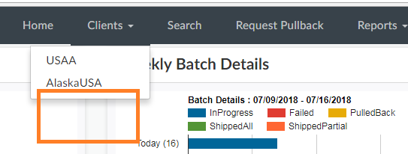
1.1 |  | Client Onboarding – Client Setup |  | - System should have an option for Client POC to configure the Client Configure POC under User Management tab of AuthoMail.  Functionalities include but not limited to:  Client Name:  Address:  Contact Person-1 Name:  Contact Person-1 Phone:  Contact Person-1 e-Mail:  Contact Person-2 Name:  Contact Person-2 Phone:  Contact Person-2 e-Mail:  Contact Person-3 Name:  Contact Person-3 Phone:  Contact Person-3 e-Mail:  IT Contact Person-1 Name:  IT Contact Person-1 Phone:  IT Contact Person-1 e-Mail:  Billing Contact Person Name:  Billing Contact Person Phone:  Billing Contact Person e-Mail:  Configure Client POC:  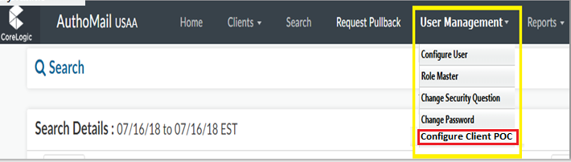  Configure Client POC Screen:  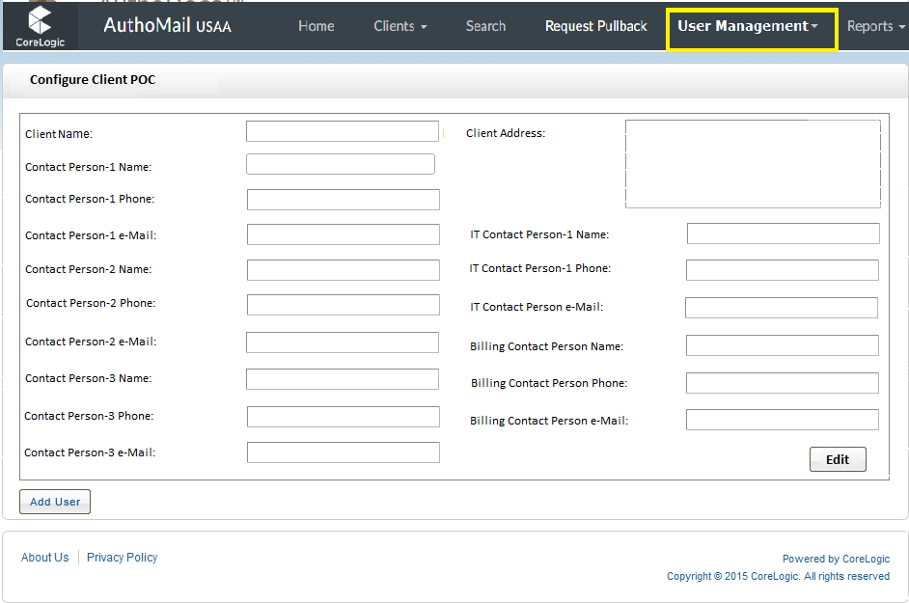  - Client Set up should be confirgured based on the below attachment for each client.  
1.2 |  | Client Onboarding – Print and Ship Project Set up |  | Services offered:  Create a tab by name Services and Cost which should have following details:  - List all the services offered by CoreLogic (refer client configuration document attached)  - FedEx service  - CoreLogic Service?  - Client Service?  - USPS service  - Client wise services and its associated cost details  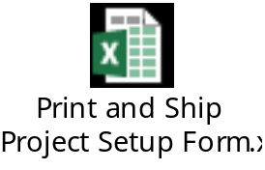
2.0 | AuthoMail | Direct Upload feature |  | - System should have an option to upload the packages directly into AuthoMail application.
2 | AuthoMail | Generic |  | - System should have static field to identify Client name (Ex: PS_ClientName)  - Data display should be dynamic based on client, need to make sure only the client specific data is displayed  - Export report option should be available for all roles in excel format.
3 | AuthoMail | Search Criteria |  | - Search Criteria to be added with Date range and Document Type  - Loan level history for document shipped by each loan  Delivery Report: (sorted by date/time received)  - Batch Number  - ID  - Package Name (Document Type)  - Loan number  - File Name  - Date received  - Date Printed  - Date Mailed  - Client Code  - Tracking number  - Shipping Method  - Customer Identifier  - Borrower First Name  - Borrower Last Name  - Street Address  - City  - State  - Zip code  - Request ID  - Pages Shipped  - Postage  Error report:  - Batch Number  - ID  - Package Name (Document Type)  - Loan number  - File Name  - Date received  - Borrower First Name  - Borrower Last Name  - Street Address  - City  - State  - Zip code  - Error Code  - Error Text
4 | AuthoMail | Billing feature |  | Need to have standardize billing template for all clients in AuthoMail. Leveraging the volume and postage reporting stored in AuthoMail.  Note: Client should not have the option to pull this report. This option should have only to CoreLogic users.  Standard Template:  
5 | AuthoMail | Reporting |  | AuthoMail should have a customized/Adhoc reporting feature, whereby Clients can run realtime queries by client name, date range, loan number, doc type, etc.  - Should have an option to pull the report based on Client wise in excel format from AuthoMail application  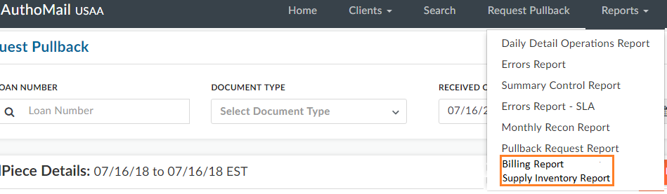  - Need to define the role to have reporting feature enabled (Admin, PnS operator, Client)  - Report: please see below sample report template  Sample Report template:  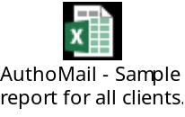
6.0 | FedEx | Latest version Integeration |  | http://sites.corelogic.net/sites/SolutionsExpress/DocumentDelivery_General/Forms/AllItems.aspx?RootFolder=%2Fsites%2FSolutionsExpress%2FDocumentDelivery%5FGeneral%2FDocumentation&FolderCTID=0x012000528E7E168EDC724C9D4C9D9927AD5A77&View={682DF217-A7CE-4A14-9E8A-80EAA8BB5618}
6.1 | FedEx | Status tracking information |  | http://sites.corelogic.net/sites/SolutionsExpress/DocumentDelivery_General/Forms/AllItems.aspx?RootFolder=%2Fsites%2FSolutionsExpress%2FDocumentDelivery%5FGeneral%2FDocumentation&FolderCTID=0x012000528E7E168EDC724C9D4C9D9927AD5A77&View={682DF217-A7CE-4A14-9E8A-80EAA8BB5618}
7.0 | USPS | Status tracking information |  | http://sites.corelogic.net/sites/SolutionsExpress/DocumentDelivery_General/Forms/AllItems.aspx?RootFolder=%2Fsites%2FSolutionsExpress%2FDocumentDelivery%5FGeneral%2FDocumentation&FolderCTID=0x012000528E7E168EDC724C9D4C9D9927AD5A77&View={682DF217-A7CE-4A14-9E8A-80EAA8BB5618}
8.0 | Search Screen | Document Type |  | - Need to have Multiple Combo box for Selection of Document Type.  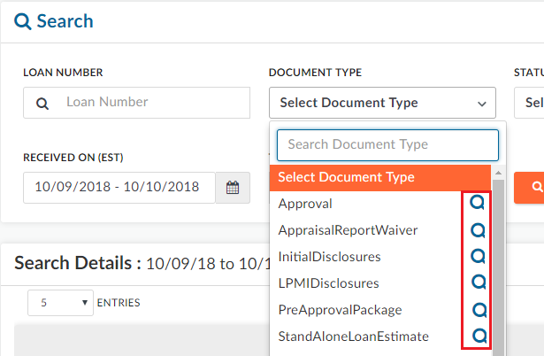  - The date range should be blank. Once it is selected then only range should reflect. (Reason: We cannot search the Loan Number without providing Date range).
9.0 | Report | Integrated Daily Recon Report |  | - AuthoMail should have an option to pull the Integrated Report (AuthoMail and TrakPCI). Please find below for reference.    - AuthoMial should have PCI BatchID.  - This option should have only to Specific User / Group.
9.1 | Report | Daily Volume with SLA Report |  | - AuthoMail should have SLA report. Please refer below attachment for the implementation.  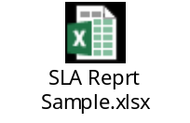  - As per below Business Rules, the SLA status should reflect the values on the report.  Business Rules:  - If the Status is “Error”, then SLA tab status should reflect as “Error”  - If the Status is “Pulled Back”, then SLA tab status should reflect as “Pulled Back”  - If the Due date & time “is lesser than” Shipped date & time, then the SLA tab status should reflect on the report as “Missed SLA”  Example:  - If the Due date & time “is greater than” Shipped date & time, then the SLA tab status should reflect on the report as “SLA Met”  Example:  - If the Status is “In Progress” and if the Current date & time “is greather than” Due date & time, then the SLA tab status should reflect on the report as “Missed SLA”  Example:  - If the Status is “In Progress” and If the Current date & time “is Lesser than” Due date & time, then the SLA tab status should reflect on the report as “Within SLA”  Example:  - This option should have only specified users / group.
  Due Date (Local) | Shipped Date (Local)
  9/20/2018 23:59 | 9/21/2018 12:21
  Due Date (Local) | Shipped Date (Local)
  9/21/2018 23:59 | 9/21/2018 12:45
  Current Date | Due Date (Local)
  9/22/2018 00:01 | 9/21/2018 23:59
  Current Date | Due Date
  9/20/2018 00:01 | 9/21/2018 23:59
9.2 | Report | SLA Miss – Email Trigger Notification |  | - Whenever there is a SLA Miss, a trigger email Notification should generate to specific Group / Users about SLA Miss anlong with Loan Number with Due dates .  - Client wise should generate.
9.3 | Report | SLA Report – Date Range |  | Need to have multiple Date range selection for Error – SLA report in AuthoMail.
9.4 | Report | Standard Daily FedEx Report |  | - System should have an option to pull Daily FedEx Report.  - Need to change Shipping date in AuthoMail to reflect the “Picked Up Date” reflected in the FedEx website tracking. (Reason: to cross check the Dates in report, FedEx and AuthoMail Application).  - If any mismatch in Shipped Date between AuthoMail Vs. FedEx Picked up date, then system should trigger an email notification stating “Shipped Date Mismatch between AuthoMail Vs. FedEx report” along with Loan Numbers.  - If the Status shows as “Not Picked up” then an email notification should trigger stating “For Loans#............, the status is showing as Not Picked up”.  - This feature should only be available to ADE Tech and Business groups.
 | Report | Daily USPS First Class Mail Report |  | - System should have an option to pull Daily USPS First Class Mail Report.  - Need to change Shipping date in AuthoMail to reflect the “Picked Up Date” reflected in the USPS website. (Reason: to cross check the Dates in report, USPS and AuthoMail Application).  - If any mismatch in Shipped Date between AuthoMail Vs. USPS Picked up date, then system should trigger an email notification stating “Shipped Date Mismatch between AuthoMail Vs. USPS First Class Mail report” along with Loan Numbers.  - This feature should have only to ADE Tech and Business groups.
 | Report | Daily USPS Priority Express Report |  | - System should have an option to pull Daily Priority Express Report.  - Need to change Shipping date in AuthoMail to reflect the “Picked Up Date” reflected in USPS site. (Reason: to cross check the Dates in report, USPS and AuthoMail Application).  - If any mismatch in Shipped Date between AuthoMail Vs. USPS, then system should trigger an email notification stating “Shipped Date Mismatch between AuthoMail Vs. USPS First Class Mail report” along with Loan Numbers.  - If the Status shows as “Not Picked up” then an email notification should trigger stating “For Loans#............, the status is showing as Not Picked up”.  - This feature should have only to ADE Tech and Business groups.
10.0 | Dashboard | Heat Map |  | - AuthoMail should have an option to select the Heat Map dashboard.  - As per attached format Heat Map dashboard should be displayed.  - This feature should have only specific users (CoreLogic Internal Use only).  - Dashboard should display based on Date wise, Document Type, Shipping Type, Status wise and Loan Number.  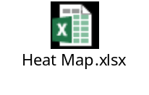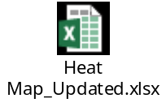

Other Technology Requirements
Priority definitions:
1 Essential – Mission critical requirement; required for current implementation
2 Critical – Required eventually but could wait until a later release, if necessary
3 Nice to Have – Would be nice to have someday if resources permit

ID # | Category  (optional) | Priority  1-Essential  2-Critical  3 –Nice to Have | Requirement Short name  (optional) | Technology Requirement Statement

Design Considerations

Implementation Impacts

Information Environment

Non-Functional System Requirements

Priority definitions:
1 Essential – Mission critical requirement; required for current implementation
2 Critical – Required eventually but could wait until a later release, if necessary
3 Nice to Have – Would be nice to have someday if resources permit

Traces To Success Metric # / User Req # / Func Req # | Category | Priority  1-Essential  2-Critical  3 –Nice to Have | Requirement Short name - Definition | Non-Functional Requirement Statement
 | Resiliency
 | Performance
1 | System Process Time | 1 | Performance | The system shall maintain existing performance SLA
 | Scalability
 | Security
 | Usability
1 | User Access | 1 | User Access | Existing user access roles and permissions will remain in effect. No new user roles shall be created as a result of this request.
 | Supportability
 | Maintainability
 | Interoperability
 | Regulatory/ Bank Compliance

Open Requirement Issues

# | Open Requirements Issues | Priority | Assigned To: | Target Date

Reviews and Approval Summary for Baseline

Reviews

Review Date | Participant | Representing

Baseline Approval Summary

Appendix

Related Documents
Document Name | Version # | Link

Definitions

Term | Description

